**Stored Procedures**

1. **This Stored Procedure will display all the medicines produced by a given medicine_supplier_id as input by the user.**

DELIMITER //

CREATE PROCEDURE `medicines_by_supplierID` (SupplierID int)

BEGIN

select * from medicines where Medicine_Supplier_Company_Supplier_ID= SupplierID;

end//

**call medicines_by_supplierID(123);**

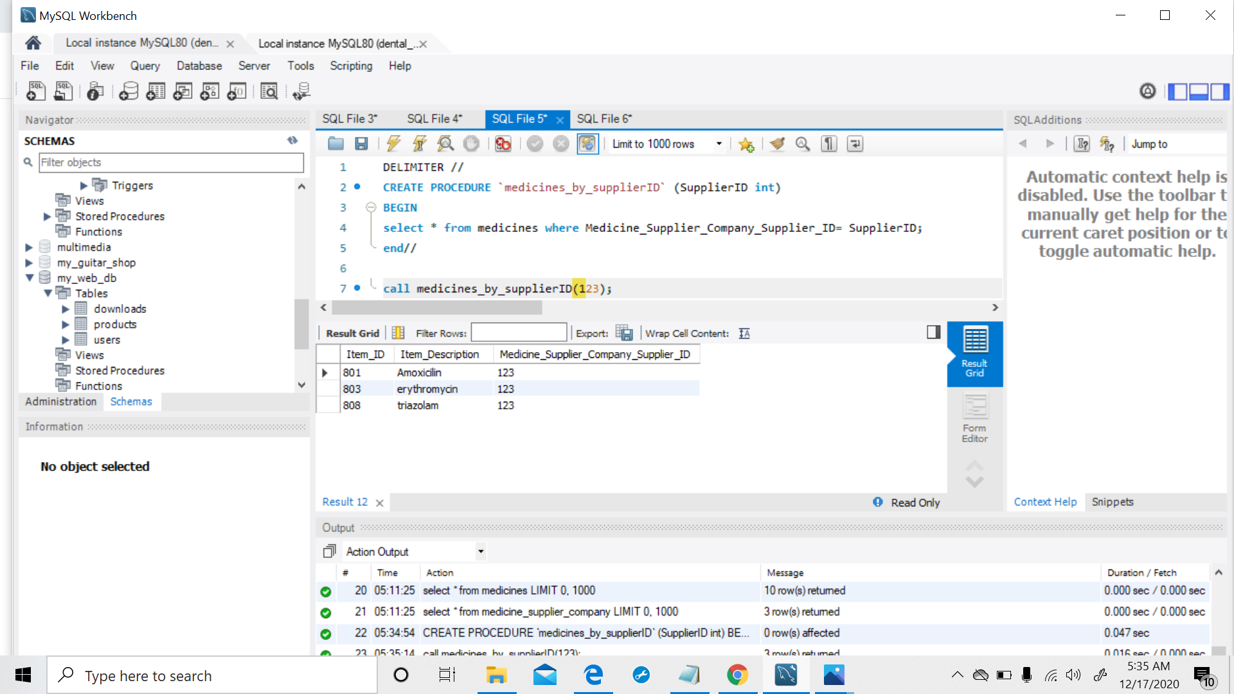

1. **This Stored Procedure will display all the visits made by a patient, given his first and last name as input by the user.**

DELIMITER //

CREATE PROCEDURE `patient_visits` (

PatientFName varchar(20),

PatientLName varchar(20))

BEGIN

select * from visits where Patients_Patient_ID = (

select Patient_ID from patients where First_Name=PatientFName

and Last_Name=PatientLname);

end//

**call patient_visits('Portia', 'Stimmel');**

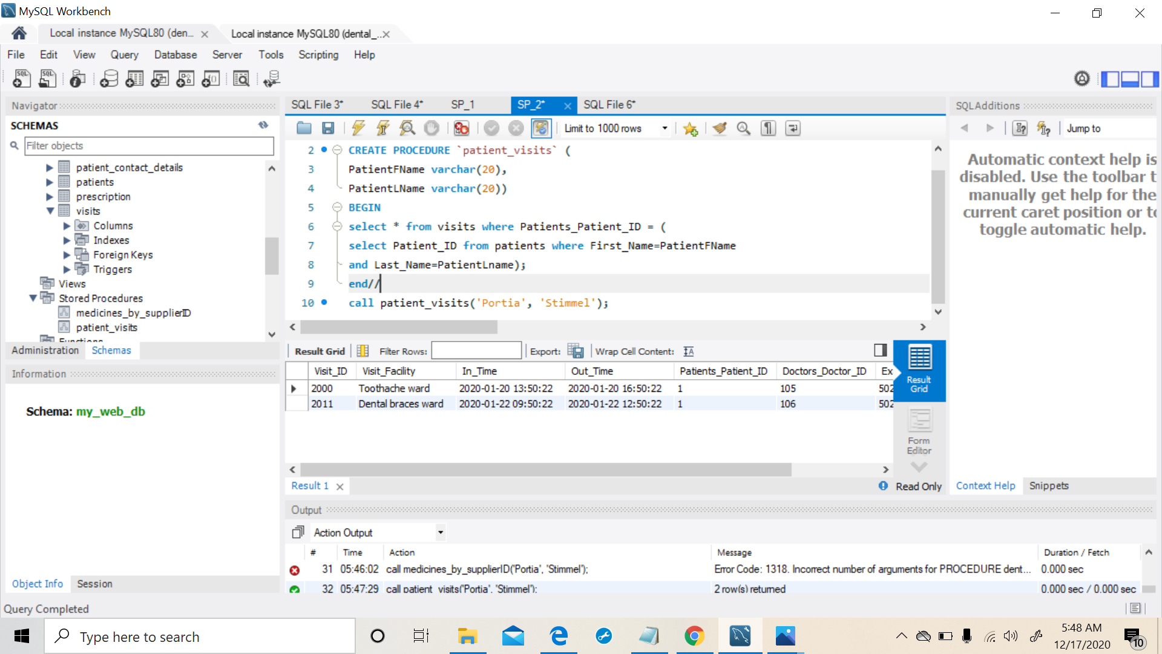

1. **This Stored Procedure will display details of all the dentists in the hospital.**

DELIMITER //

CREATE PROCEDURE `all_dentists_details` ()

BEGIN

select * from doctors;

end//

**call all_dentists_details();**

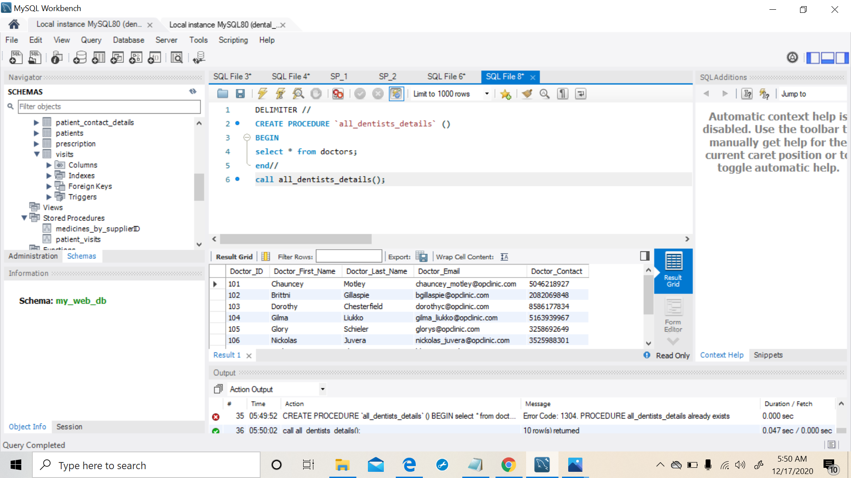

1. **This Stored Procedure is used to update a patients bill**

select * from patient_bills where visits_visit_id = 2010;

DELIMITER //

CREATE PROCEDURE update_bill(new_bill int, visit_id int)

BEGIN

UPDATE patient_bills

SET total_bill = new_bill, balance_due = total_bill - Insuance_Amount

WHERE visits_visit_id = visit_id;

end//

**Before:**

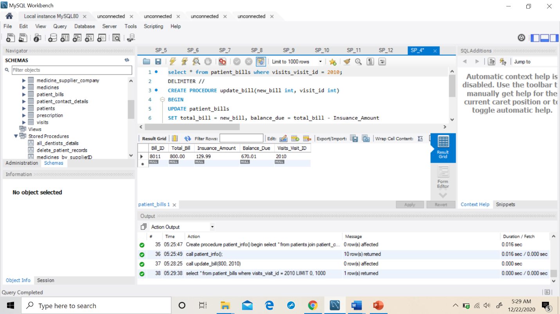

**call update_bill(1000, 2010);**

**After:**

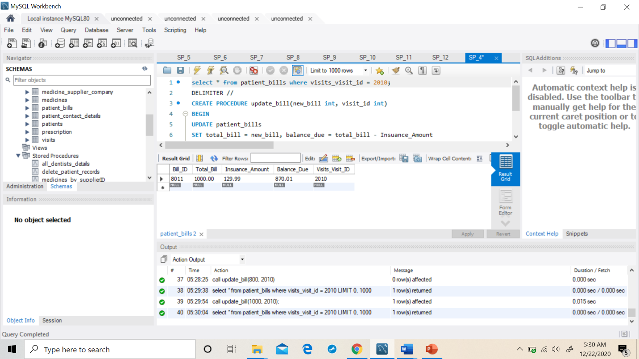

1. **This Stored Procedure will display number of visits made by all the patients**

DELIMITER //

CREATE PROCEDURE num_of_visits()

BEGIN

SELECT CONCAT(First_name," ",Last_name) as Patient_Full_Name,

count(v.patients_patient_id) "Number_of_visits"

FROM visits v

JOIN patients p

ON v.patients_patient_id=p.patient_id

GROUP BY patient_Full_name

HAVING count(v.patients_patient_id)>=1

ORDER BY number_of_visits DESC;

end//

**call num_of_visits();**

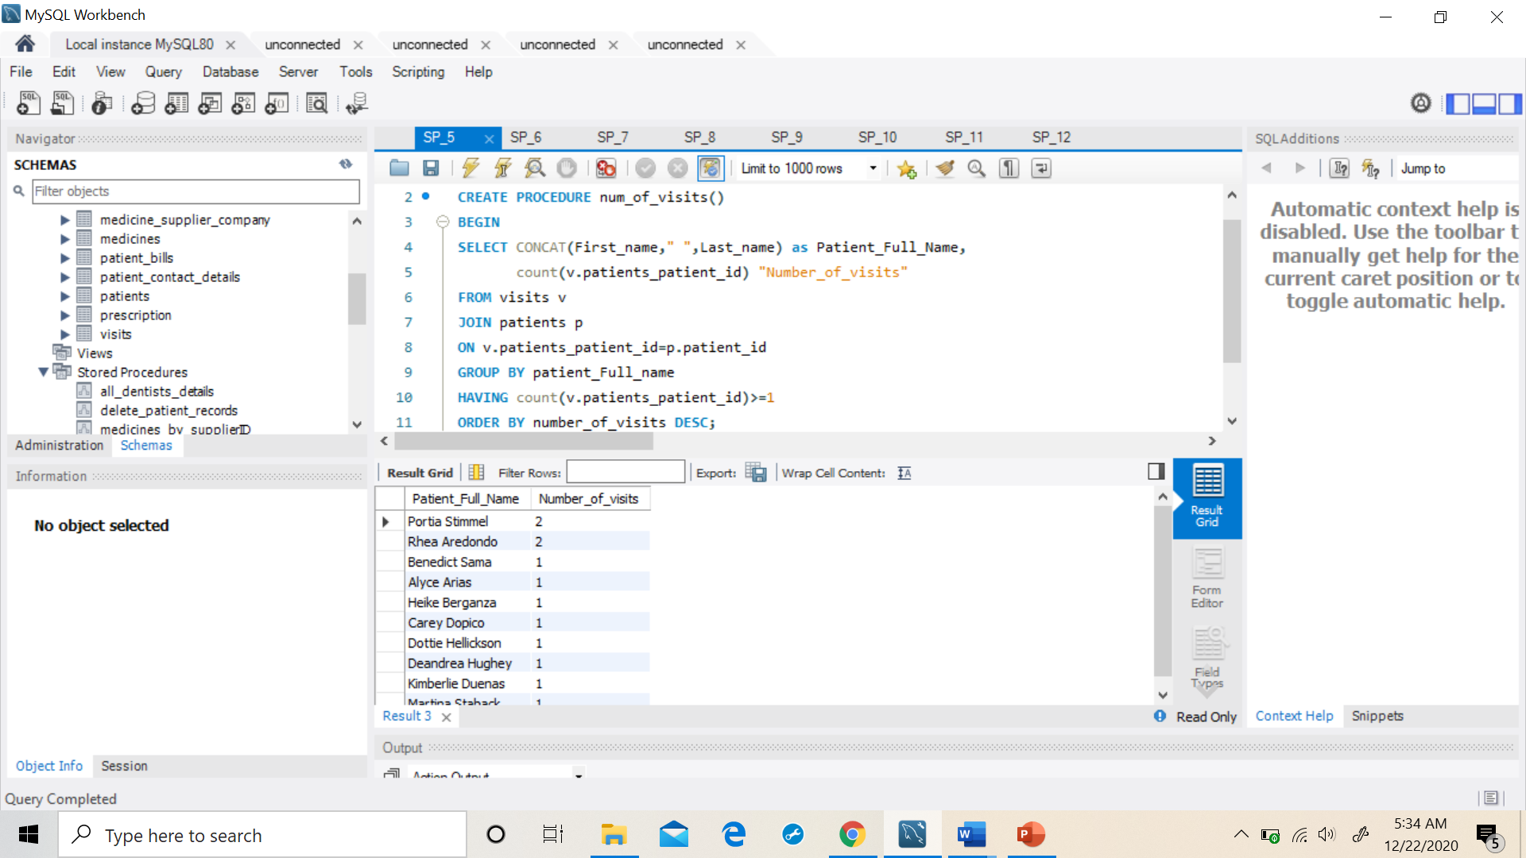

1. **This Stored Procedure will update a patient_contact_details when their address is changed.**

DELIMITER //

CREATE PROCEDURE update_patient_details(

Patient_ID int,

new_Home varchar(30),

new_city varchar(30),

new_state varchar(30))

BEGIN

UPDATE patient_contact_details SET Home_Address= new_Home,

city = new_city, state = new_state WHERE patients_patient_id=Patient_ID;

end//

**Before:**

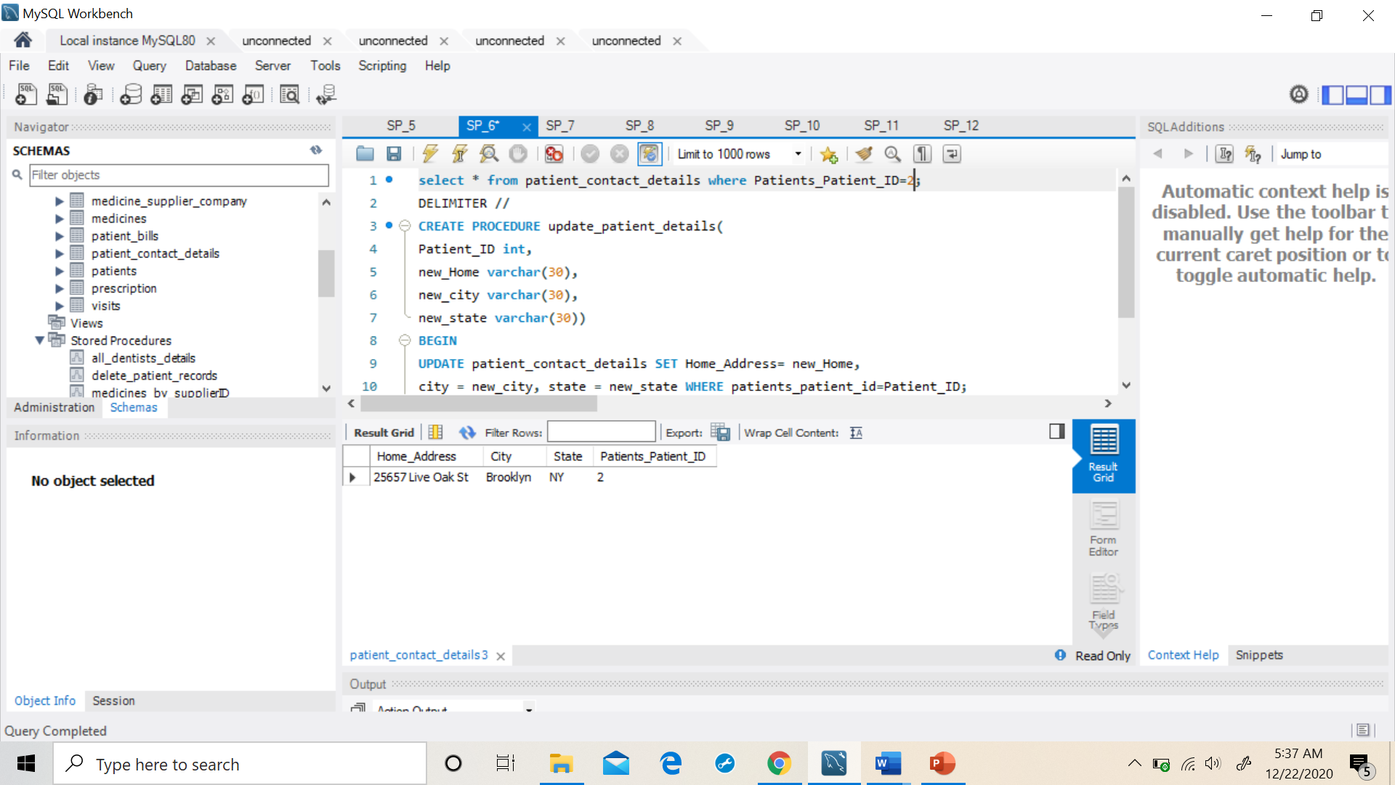

**call update_patient_details(2,'9523 UT','Dallas','Texas')**

**After:**

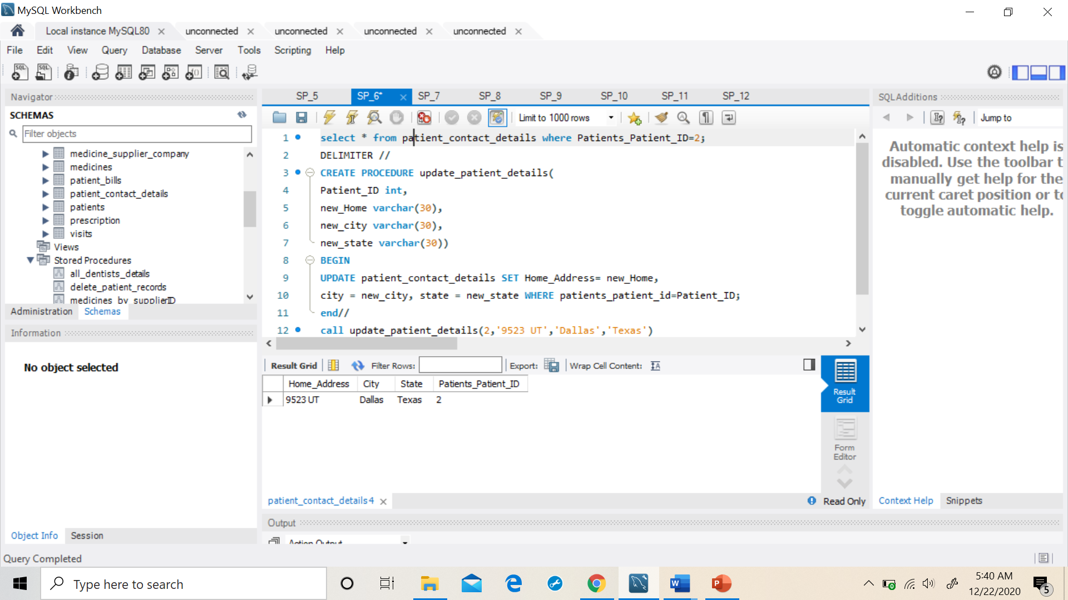

1. **This Stored Procedure will insert a new dentist record whenever a new dentist joins the hospital.**

DELIMITER //

Create procedure new_dentists

(

doc_id int,

doc_first_name varchar(20) ,

doc_last_name varchar(20),

doc_email varchar(30),

doc_contact varchar(50)

)

begin

insert into doctors values (doc_id,doc_first_name,doc_last_name,

doc_email,doc_contact);

end //

**Before:**

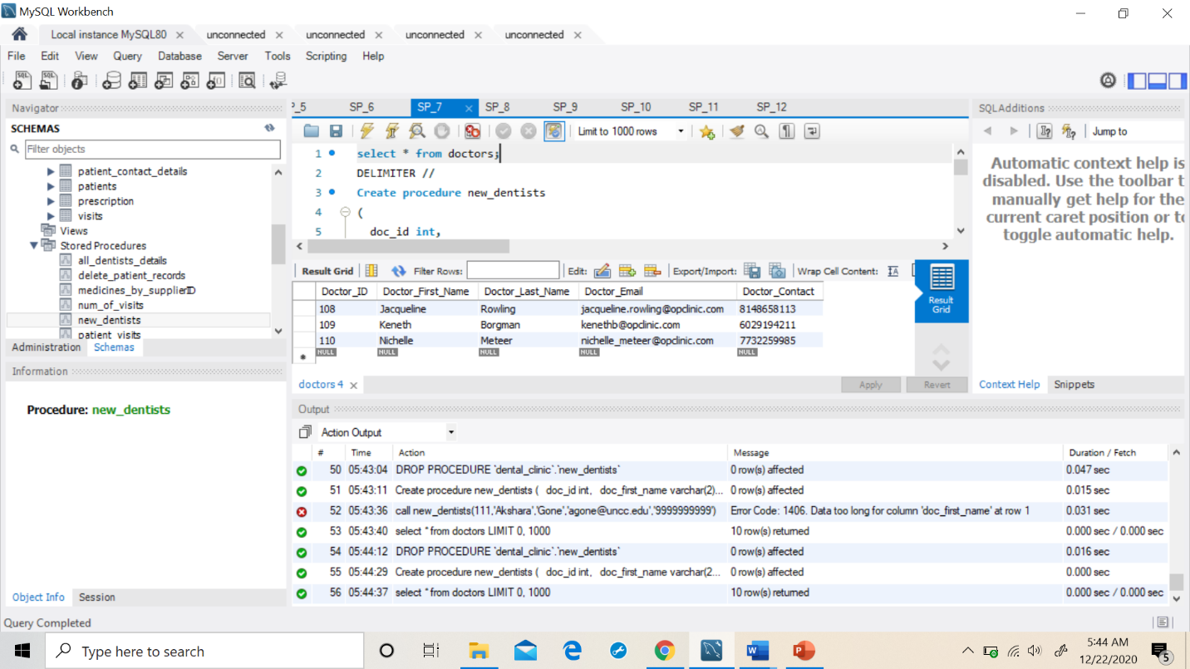

**call new_dentists(111,'Akshara','Gone','agone@uncc.edu','9999999999')**

**After:**

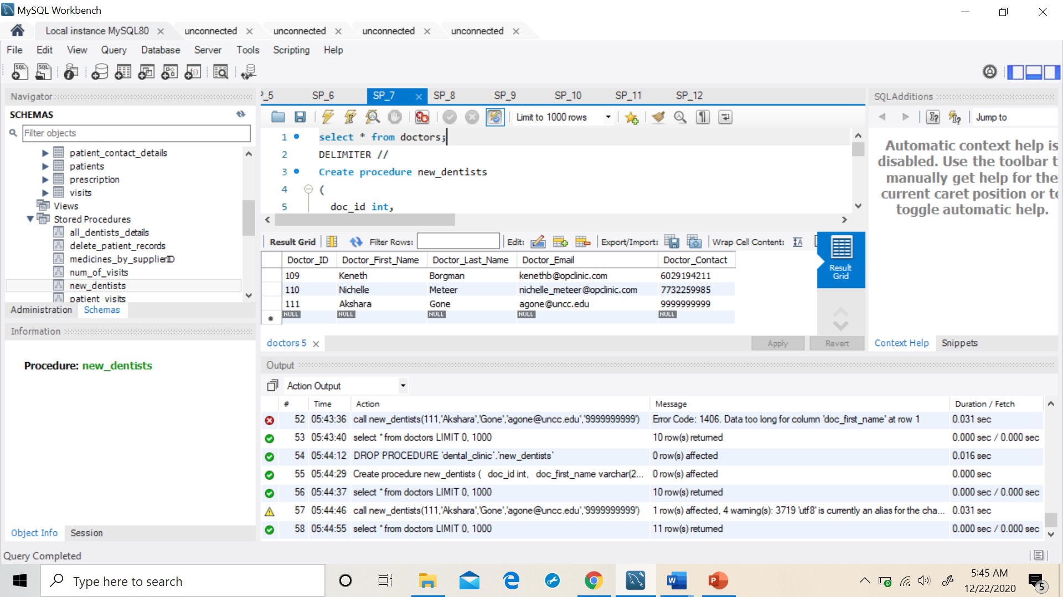

1. **This Stored Procedure is used to perform Update, Insert or Delete operations on the health_insurance_provider table.**

select * from health_insurance_provider where Company_ID=121 ;

DELIMITER //

CREATE PROCEDURE queries_on_insurance

(

company_id int ,

company_name varchar(40),

company_location varchar(40),

company_contact varchar(40),

query_type char(1)

)

begin

SET FOREIGN_KEY_CHECKS=OFF;

if (query_type ='I') then

INSERT INTO health_insurance_provider values (company_id,company_name,

company_location,company_contact);

elseif (query_type ='U') then

UPDATE health_insurance_provider set Company_Name=company_name,

Company_Location=company_location, Company_Contact=company_contact where

Company_ID=company_id;

elseif (query_type ='D') then

DELETE from health_insurance_provider where Company_ID=company_id;

End if;

SET FOREIGN_KEY_CHECKS=ON;

end //

**Before UPDATE operation**

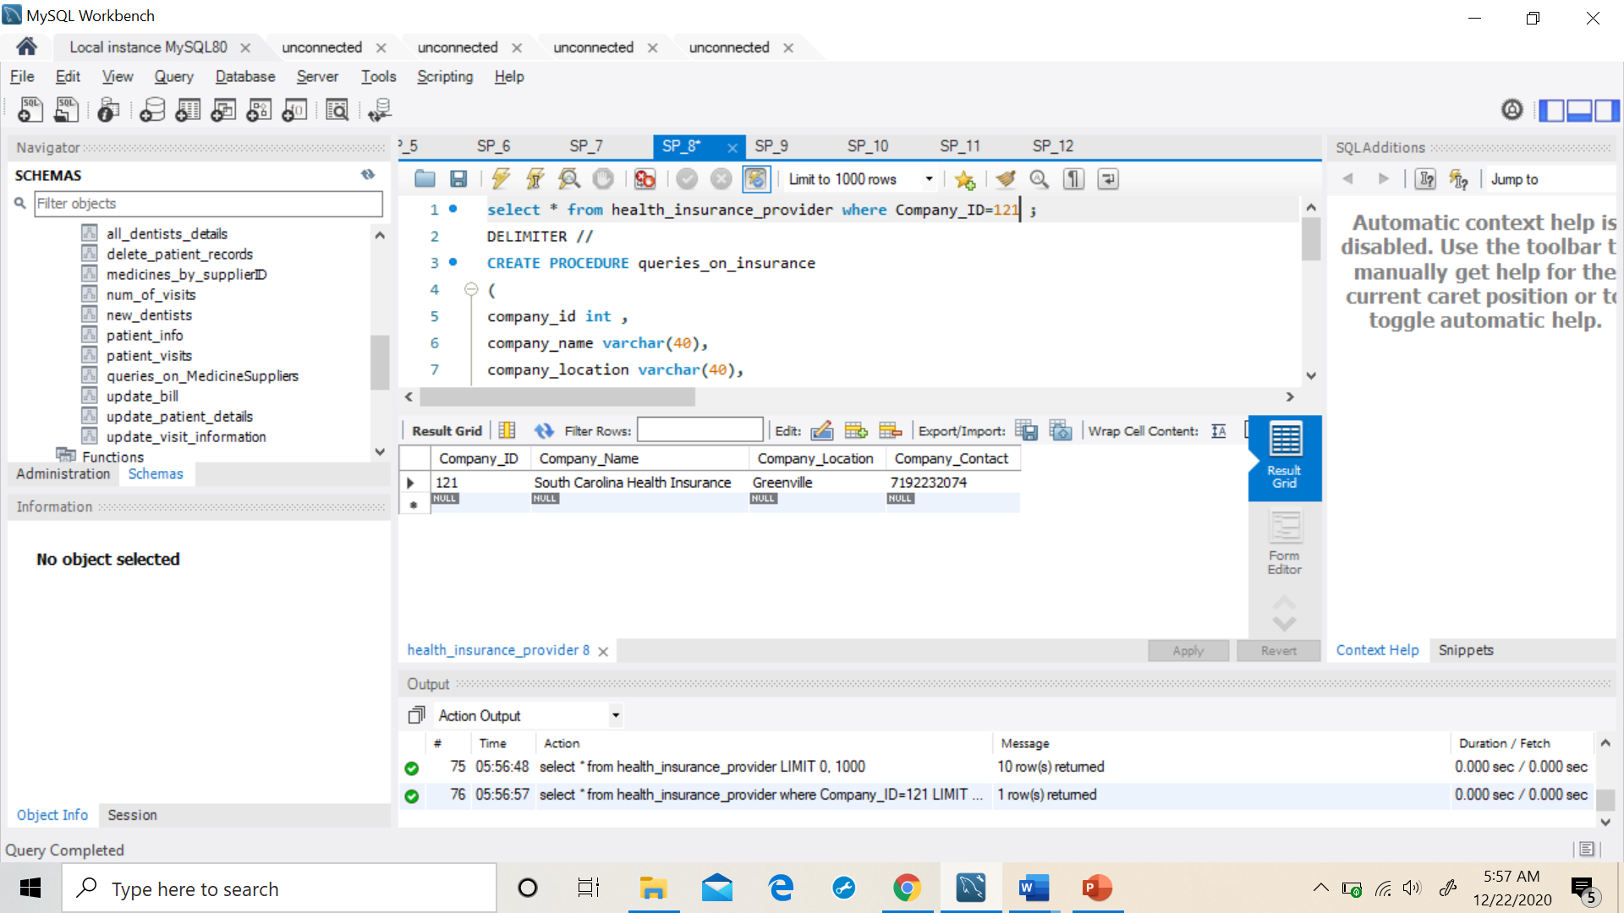

**call queries_on_insurance(129,'BCBS','Nashville','9192232074','U');**

**After UPDATE operation**

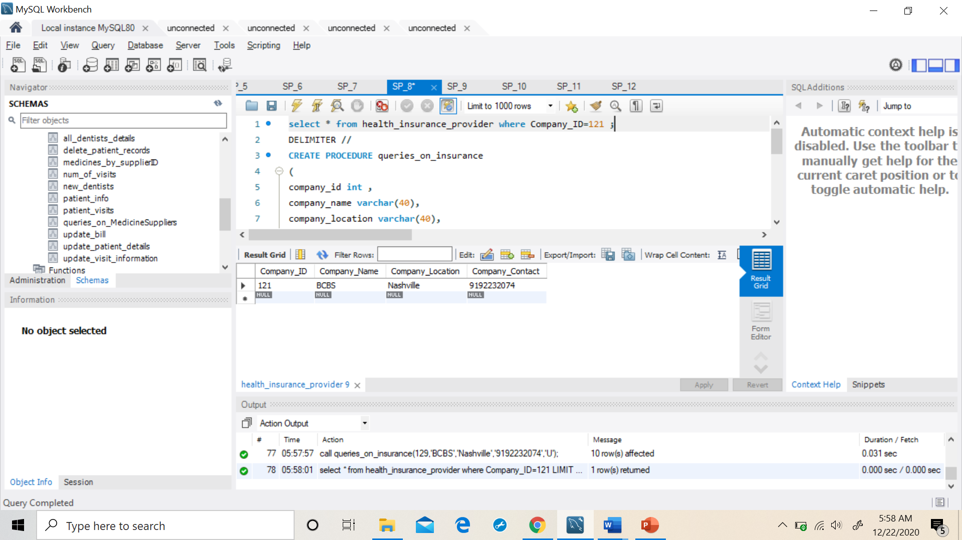

1. **This Stored Procedure is used to delete a patients record from the hospital database. (Deletes all the records from all the tables related to a patients)**

select * from patients where Patient_ID=10;

DELIMITER //

Create procedure delete_patient_records

(

p_id int

)

begin

SET FOREIGN_KEY_CHECKS=OFF;

DELETE from patient_contact_details where Patients_Patient_ID=p_id;

DELETE from visits where Patients_Patient_ID=p_id;

DELETE from patients where Patient_ID=p_id;

SET FOREIGN_KEY_CHECKS=ON;

end //

**call delete_patient_records(10);**

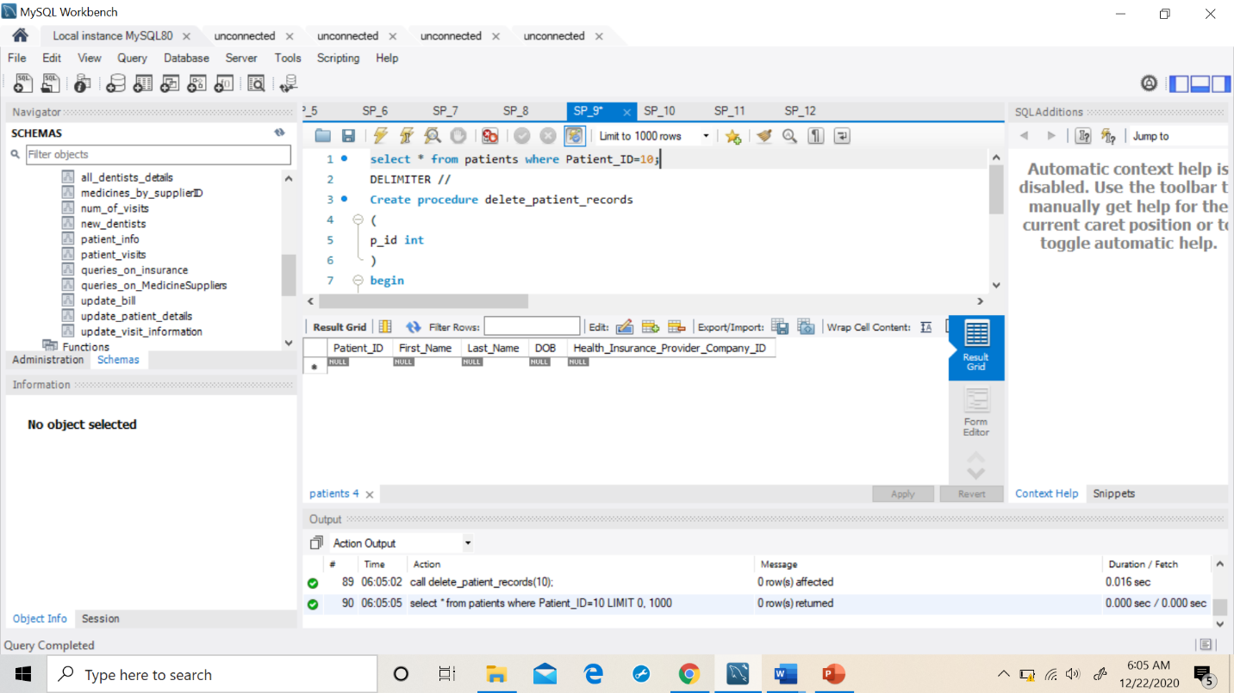

**10. This Stored Procedure is used to update the reason for hospital visit of a patient information in the visits table.**

select * from visits where visit_id=2000;

DELIMITER //

Create procedure update_visit_information

(

visit_id int,

p_id int,

visit_facility varchar(20),

doc_id int

)

begin

UPDATE visits set Visit_Facility=visit_facility,

Doctors_Doctor_ID=doc_id where Visit_ID=visit_id

and Patients_Patient_ID=p_id;

end //

**Before:**

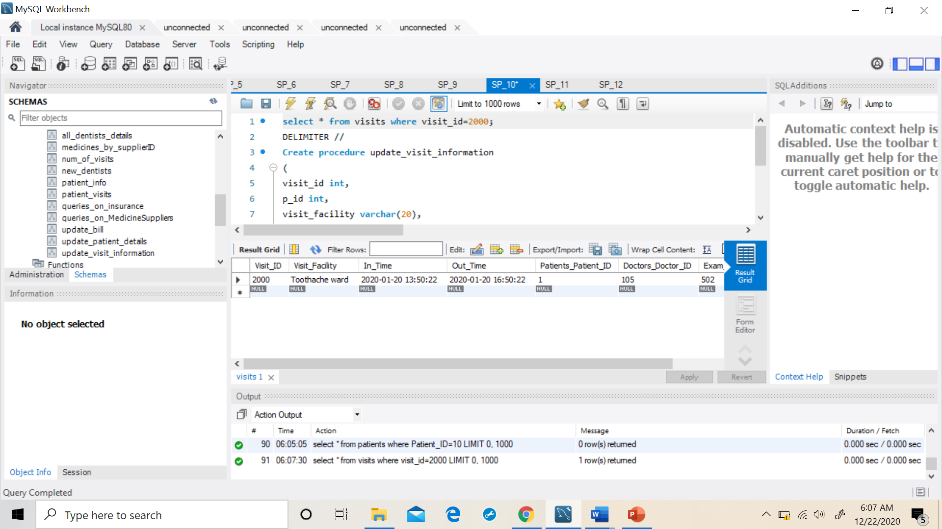

**call update_visit_information(2000,1,'Braces Ward',102);**

**After:**

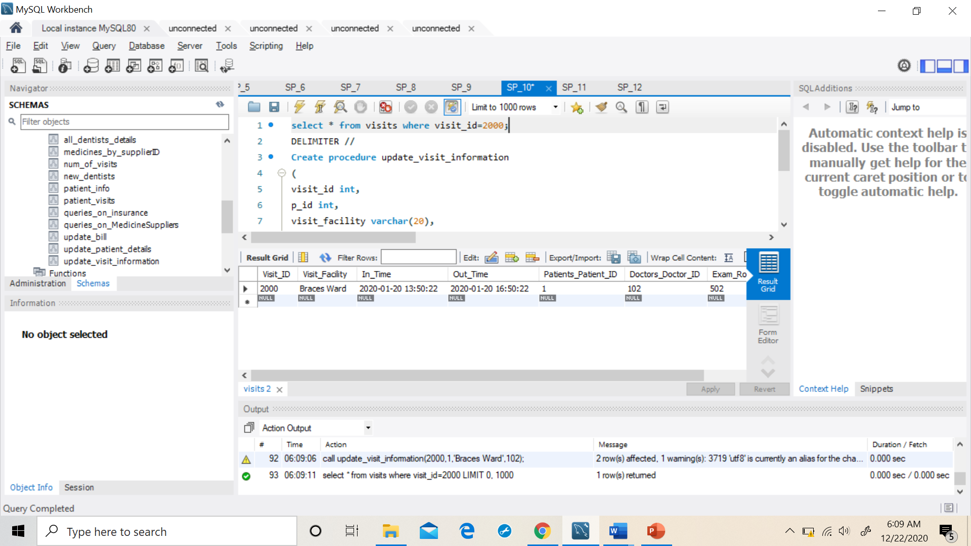

**11. This Stored Procedure is used to perform Update, Insert or Delete operations on the medical_supplier_company table.**

select * from medicine_supplier_company;

DELIMITER //

CREATE PROCEDURE queries_on_MedicineSuppliers

(

sup_id int ,

sup_name varchar(40),

sup_address varchar(40),

sup_contact varchar(40),

query_type char(1)

)

begin

SET FOREIGN_KEY_CHECKS=OFF;

if (query_type ='I') then

INSERT INTO medicine_supplier_company values (sup_id,sup_add,

sup_name,sup_contact);

elseif (query_type ='U') then

UPDATE medicine_supplier_company set Supplier_Name=sup_name,

Supplier_Address=sup_address, sup_contact=sup_contact where

Supplier_ID=sup_id;

elseif (query_type ='D') then

DELETE from medicine_supplier_company where Supplier_ID=sup_id;

End if;

SET FOREIGN_KEY_CHECKS=ON;

end //

**Before DELETE operation:**

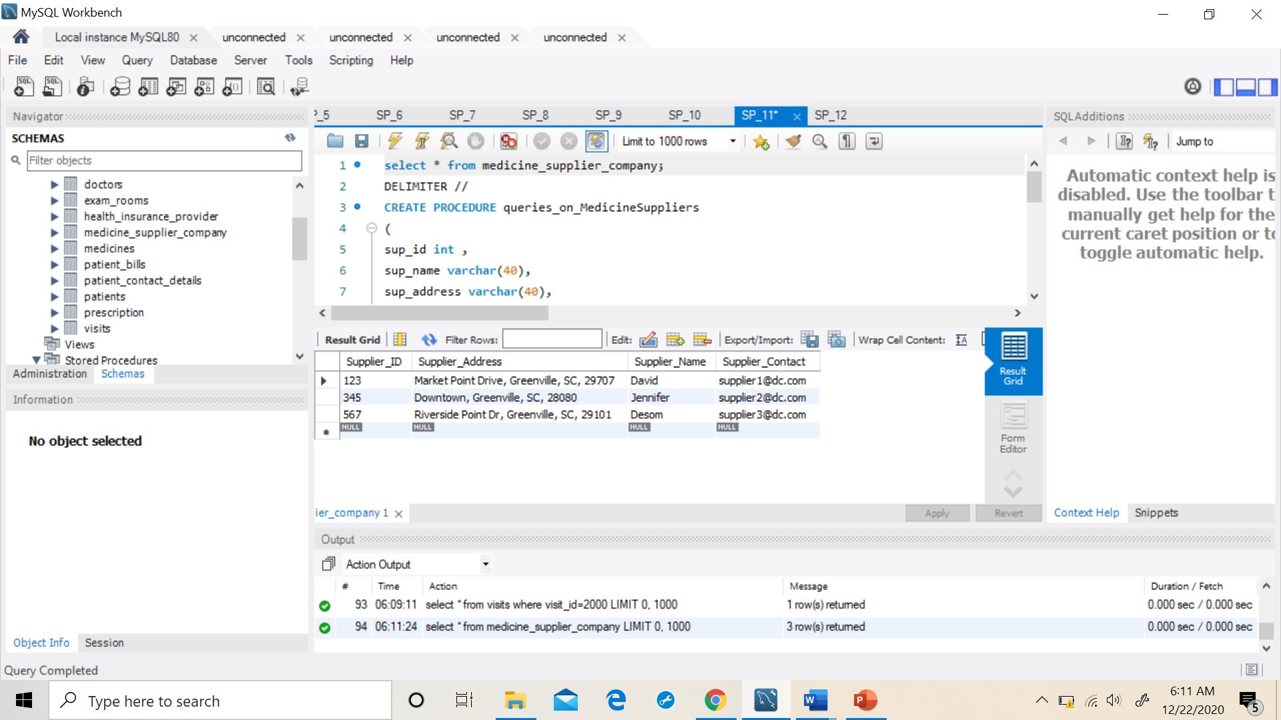

**call queries_on_MedicineSuppliers(567,'','','','D');**

**After the DELETE Operation:**

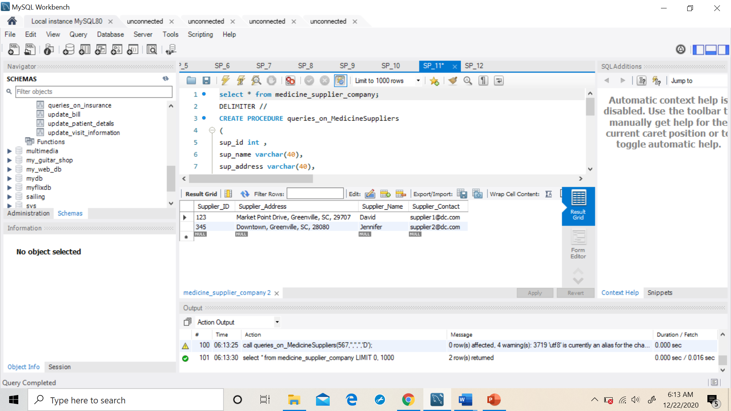

**12. This Stored Procedure is used to view all the patients complete Information by joining the patients and patient_contact_details information.**

DELIMITER //

Create procedure patient_info()

begin

select * from patients join patient_contact_details on

patients.Patient_ID=patient_contact_details.Patients_Patient_ID;

end //

**call patient_info();**

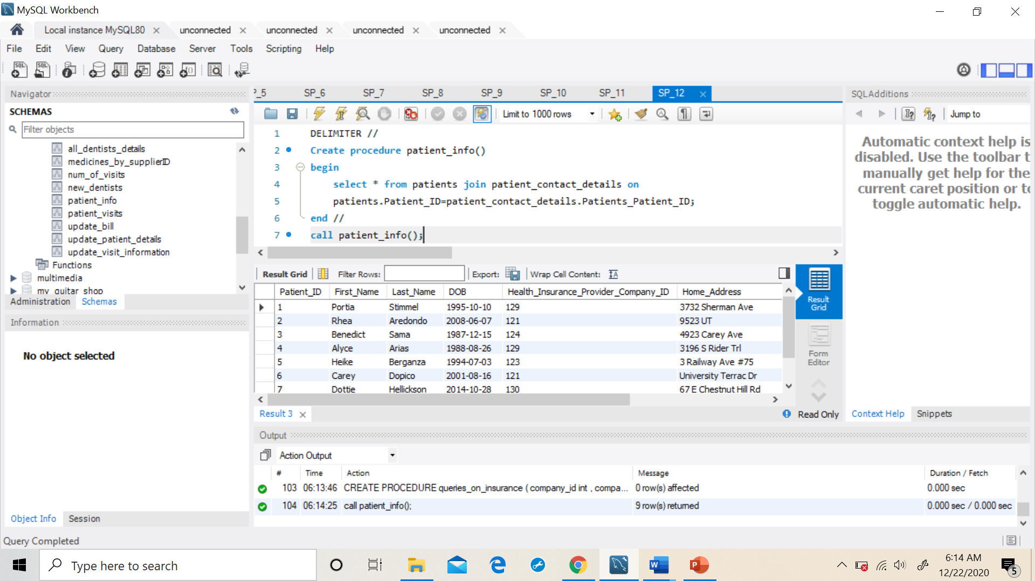

**Example**

**The user need not write the SQL script to check what medicies are supplied by a specific supplier company. The user should just Run the stored procedure ‘medicines_by_supplierID’ and enter the Supplier_ID in the column as shown below.**

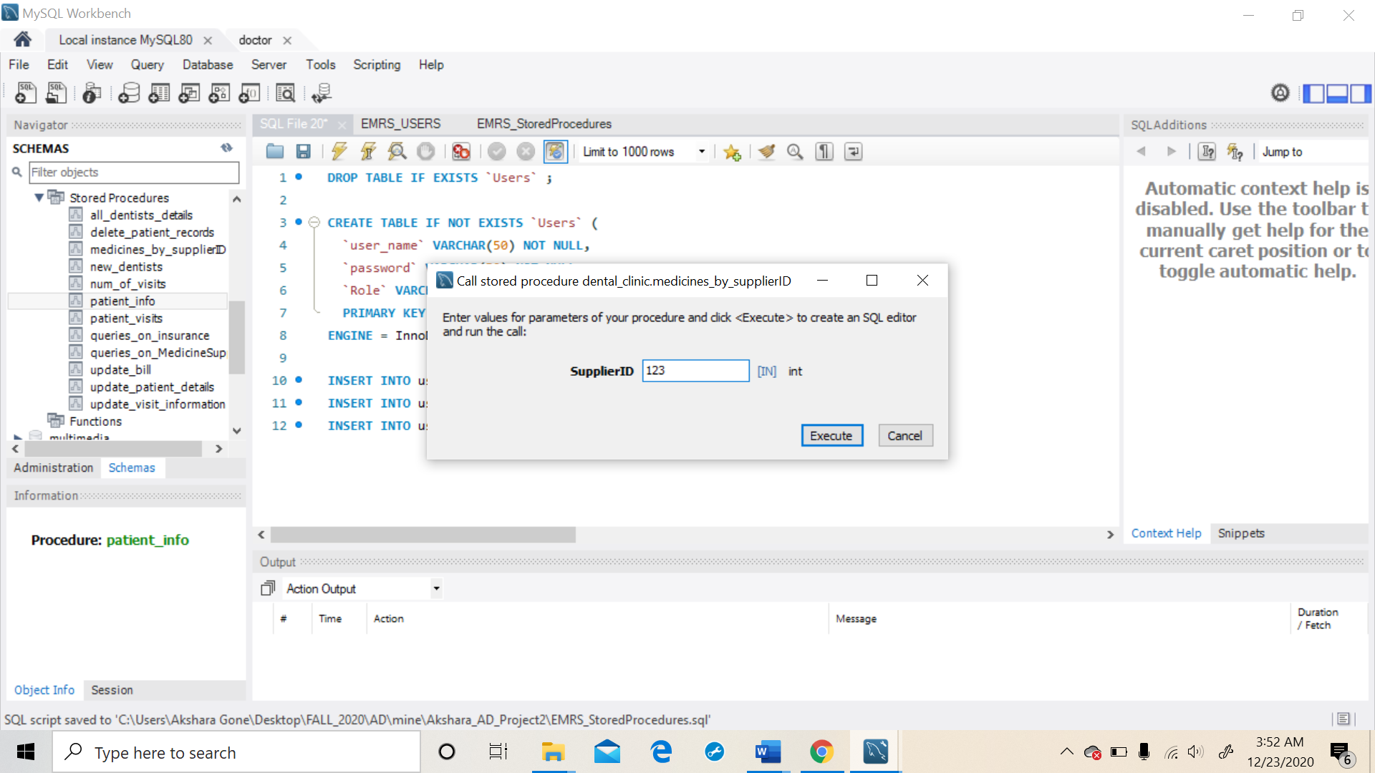

**After entering the Supplier_ID, execute the procedure and the output is displayed as shown below.**

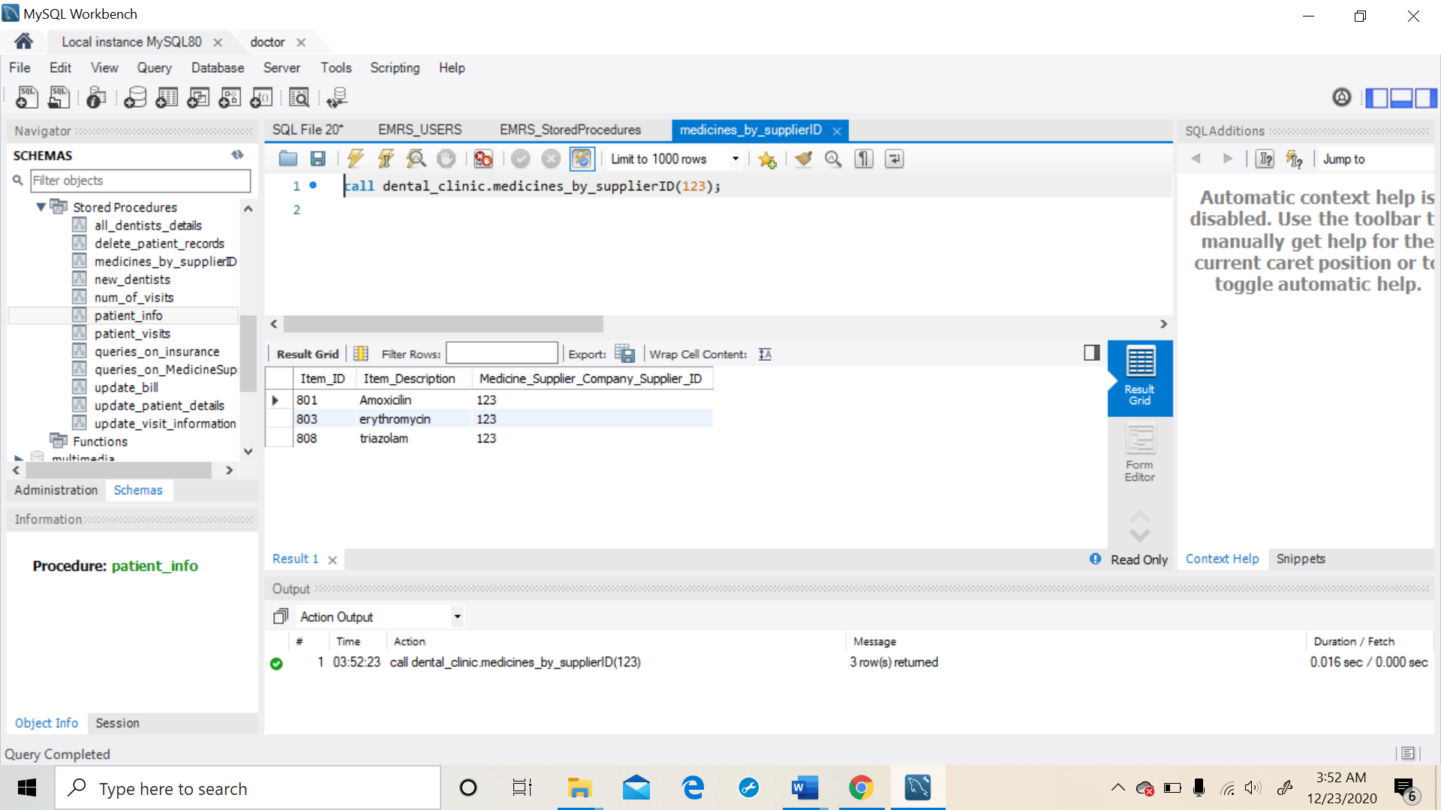

**In this way, users can perform operation on the database using Stored Procedures without actually writing the SQL scripts.**